Phishing Email Analysis – Sample Report

Task 1:

  - Is Email #1 a phishing email? Why or Why not? Please provide screenshot indicating your assessment and explain the same in words. (3 points)

Answer:

Based on the analysis on email #1 no security vendor was flagged the URL as malicious, and the analysis shows the URLs are Clean, therefore this does not appear to be phishing email at the time.

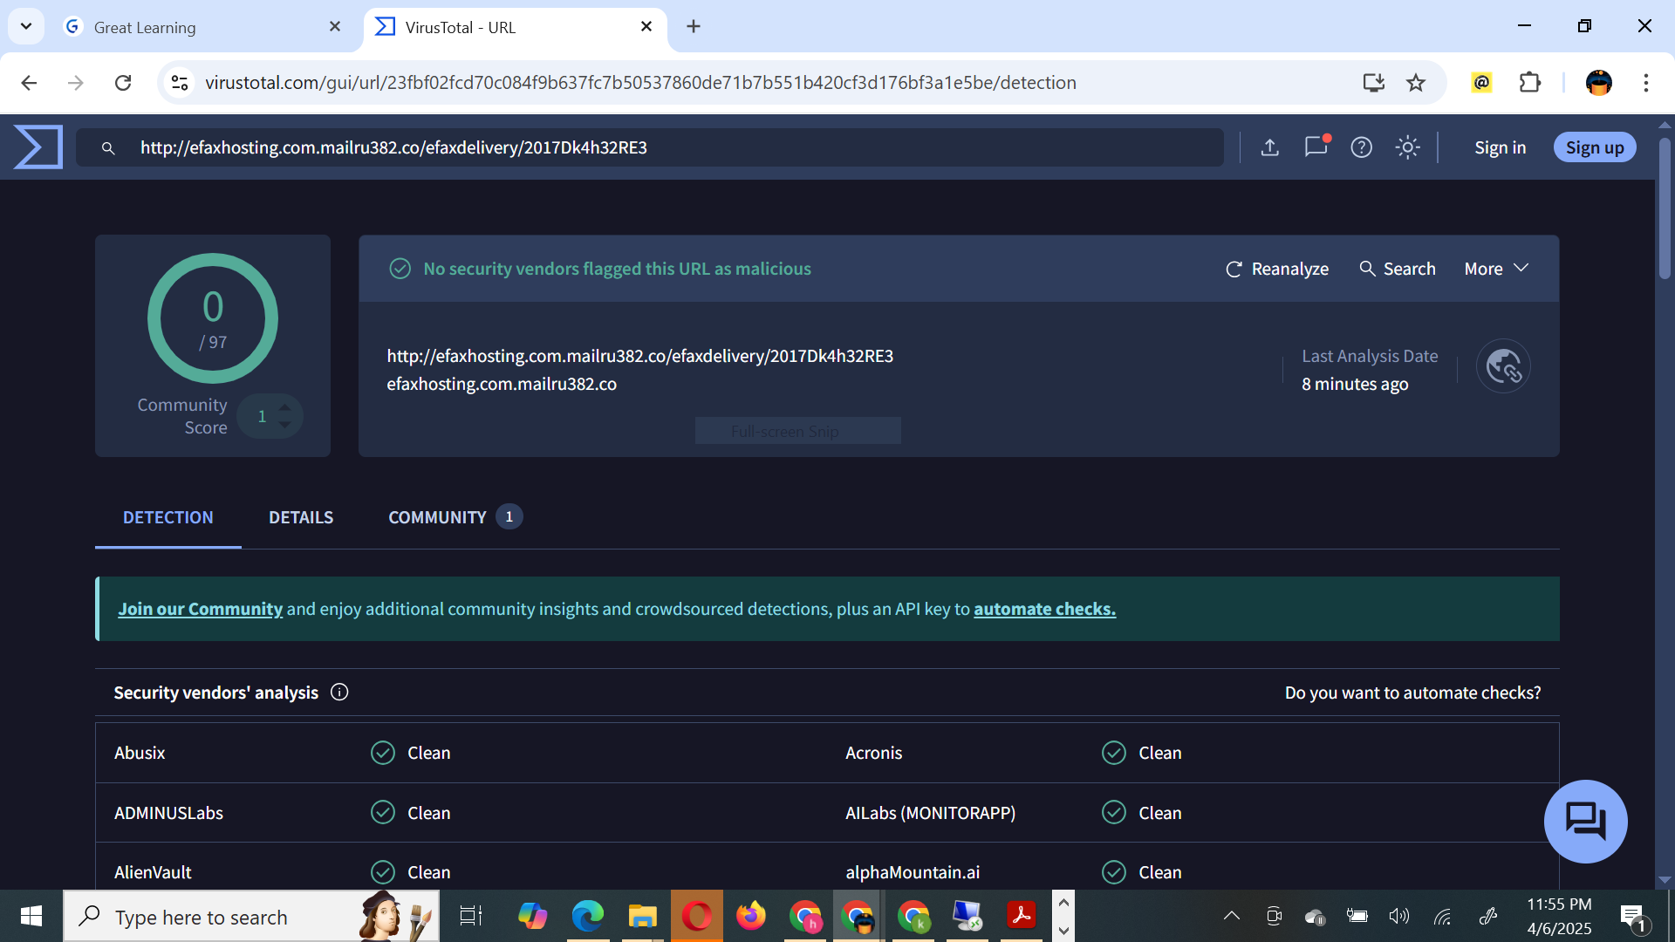

  - Is Email #2 a phishing email? Why or Why not? Please provide screenshot indicating your assessment and explain the same in words. (3 points)

Answer:

Based on the email #2 analysis showing that 8 out of 97 security vendors have flagged the URL as malicious, particularly for phishing, this URL is likely associated with a phishing email and should be considered potentially harmful.

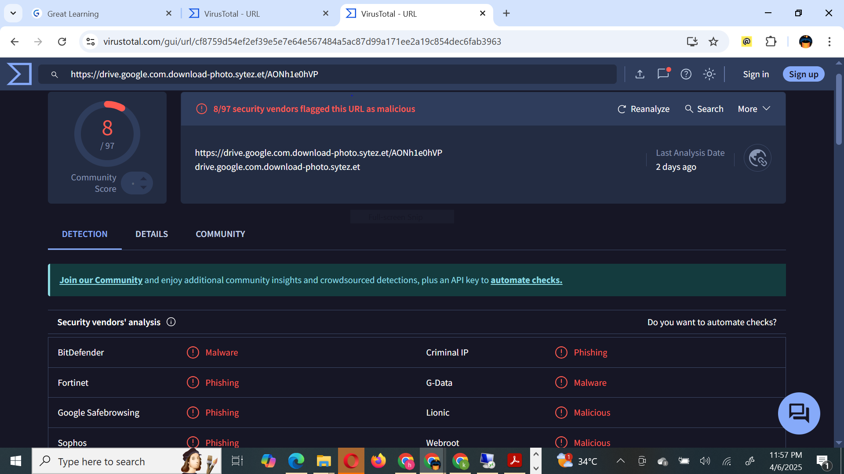

  - Is Email #3 a phishing email? Why or Why not? Please provide screenshot indicating your assessment and explain the same in words. (3 points)

Answer:

Based on the analysis on email #3 no security vendor was flagged the URL as malicious, and the analysis shows the URLs are Clean, therefore this does not appear to be phishing email at the time

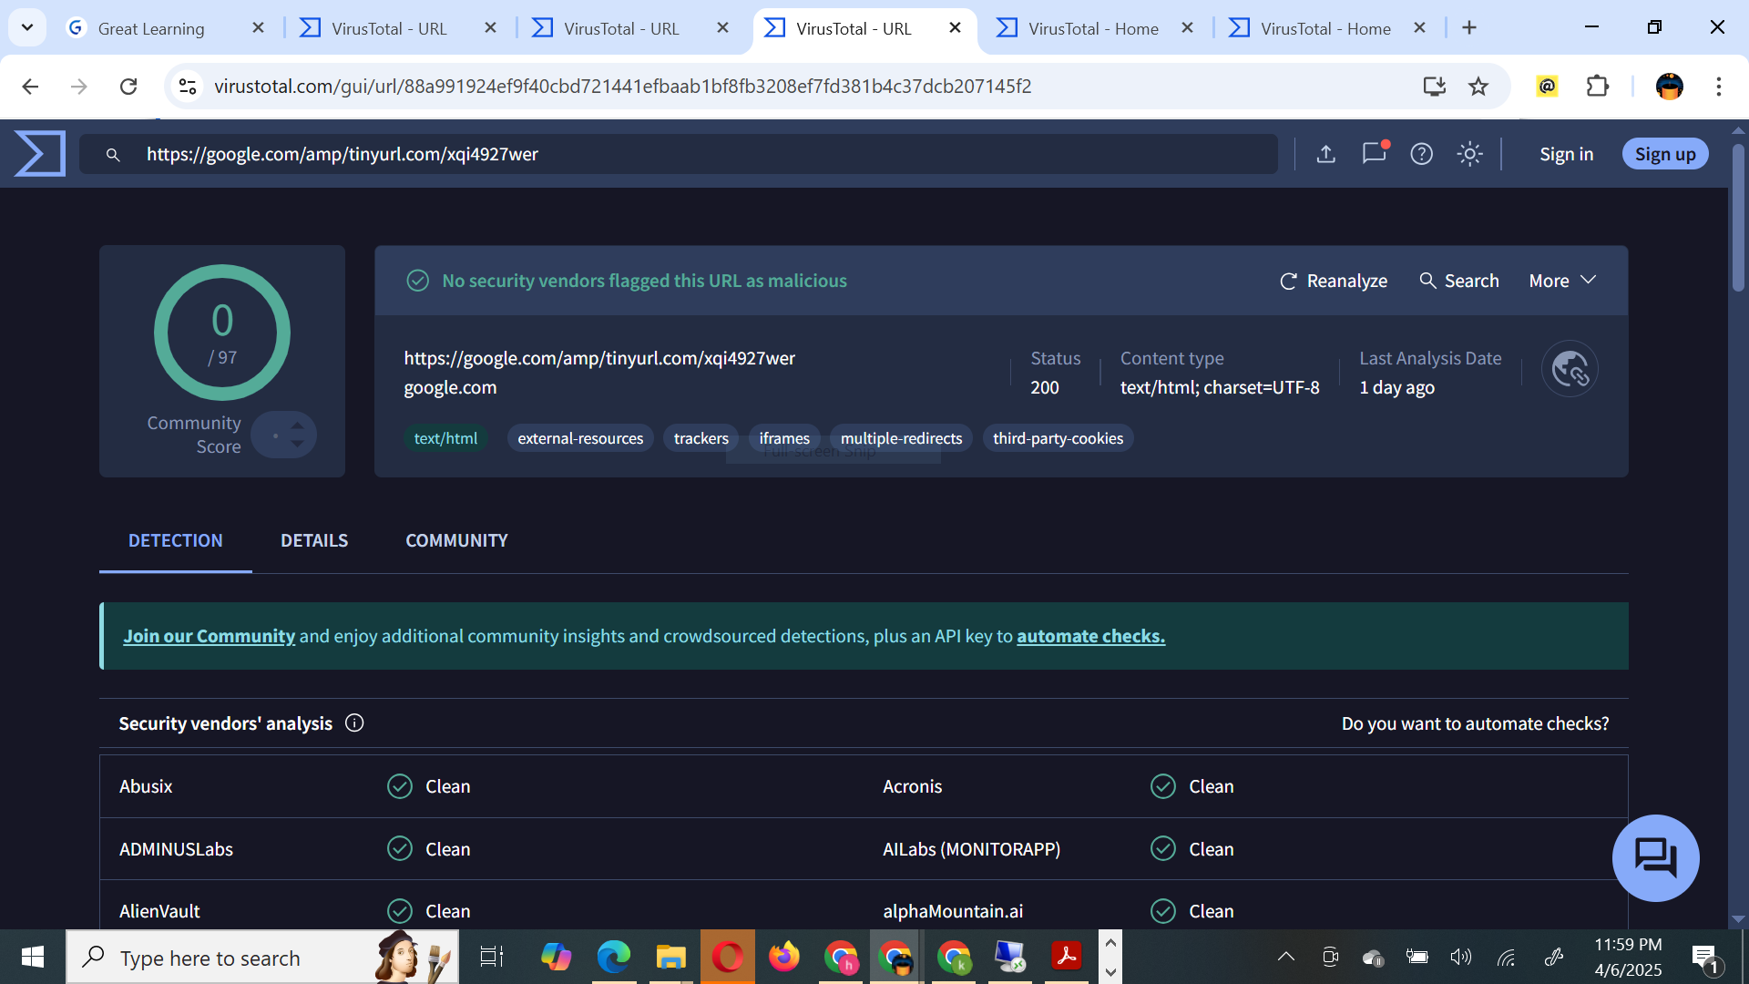

  - Is Email #4 a phishing email? Why or Why not? Please provide screenshot indicating your assessment and explain the same in words. (3 points)

Answer:

Based on the analysis on email #4 no security vendor was flagged the URL as malicious, and the analysis shows the URLs are Clean, therefore this does not appear to be phishing email at the time

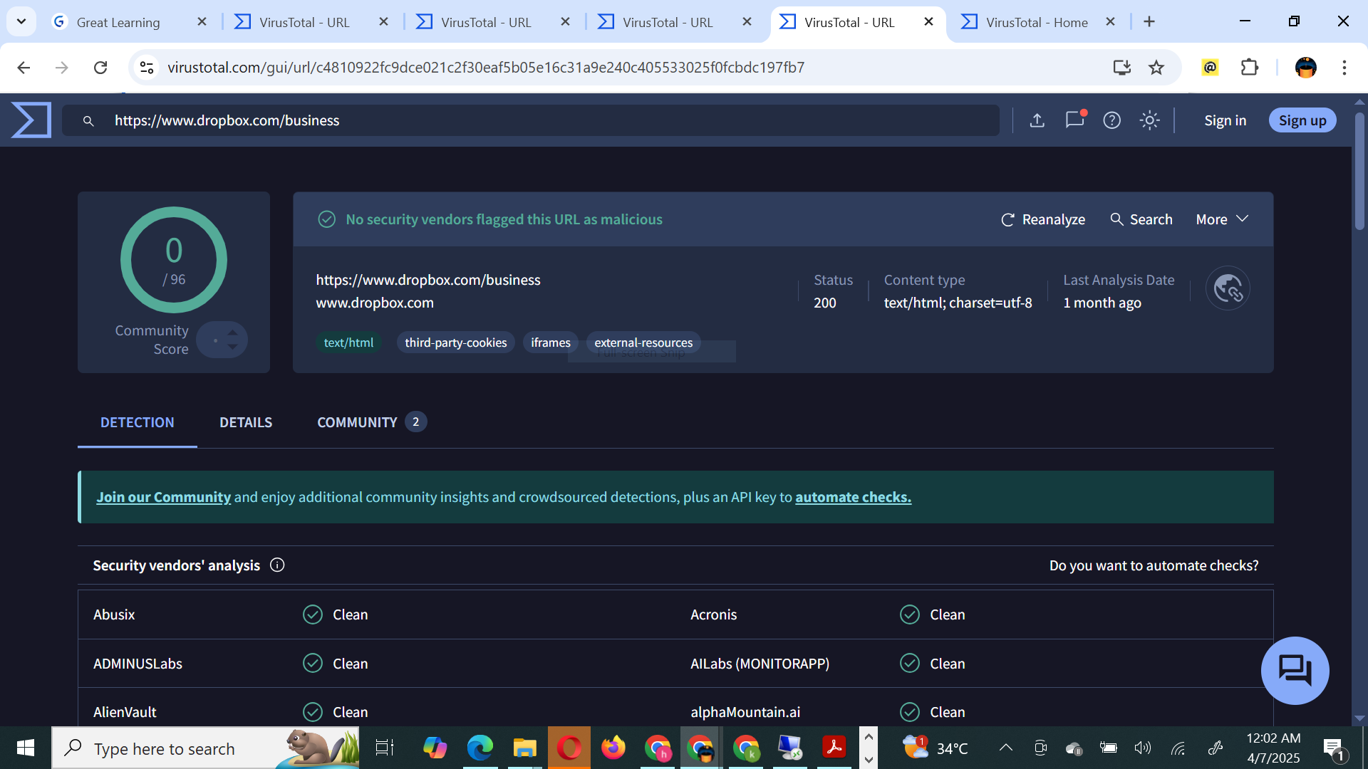

  - Is Email #5 a phishing email? Why or Why not? Please provide screenshot indicating your assessment and explain the same in words. (3 points)

Answer:

Based on the analysis on email #5 showing that 11 out of 97 security vendors have flagged the URL associated with this email as malicious specifically for phishing this email should be considered a high risk phishing attempt and should not be interacted with.

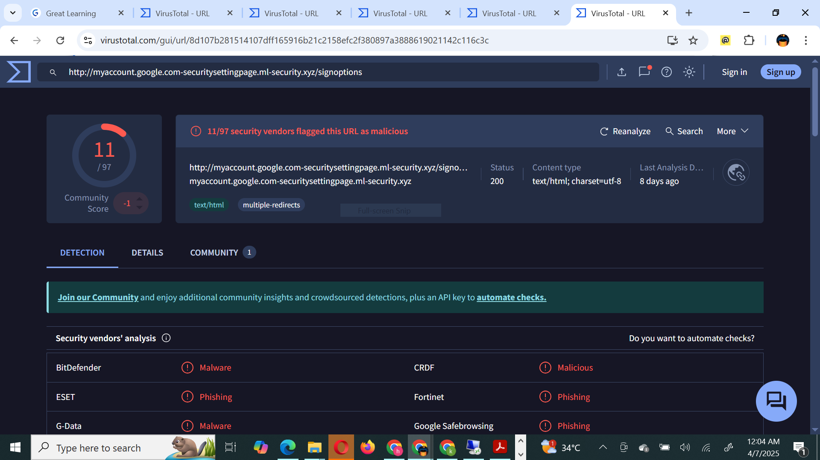

Task 2:

- Is URL #1 a malicious URL? Why or Why not? Explain.
Share screenshots of the results from Virustotal which provides evidence of your conclusion (malicious/not malicious) (3 Points)

Answer:
Based on the security vendor analysis shown in the virustotal, which indicates that the URL #1 is assessed as "Clean" by multiple reputable security vendors, this URL does not appear to be malicious.

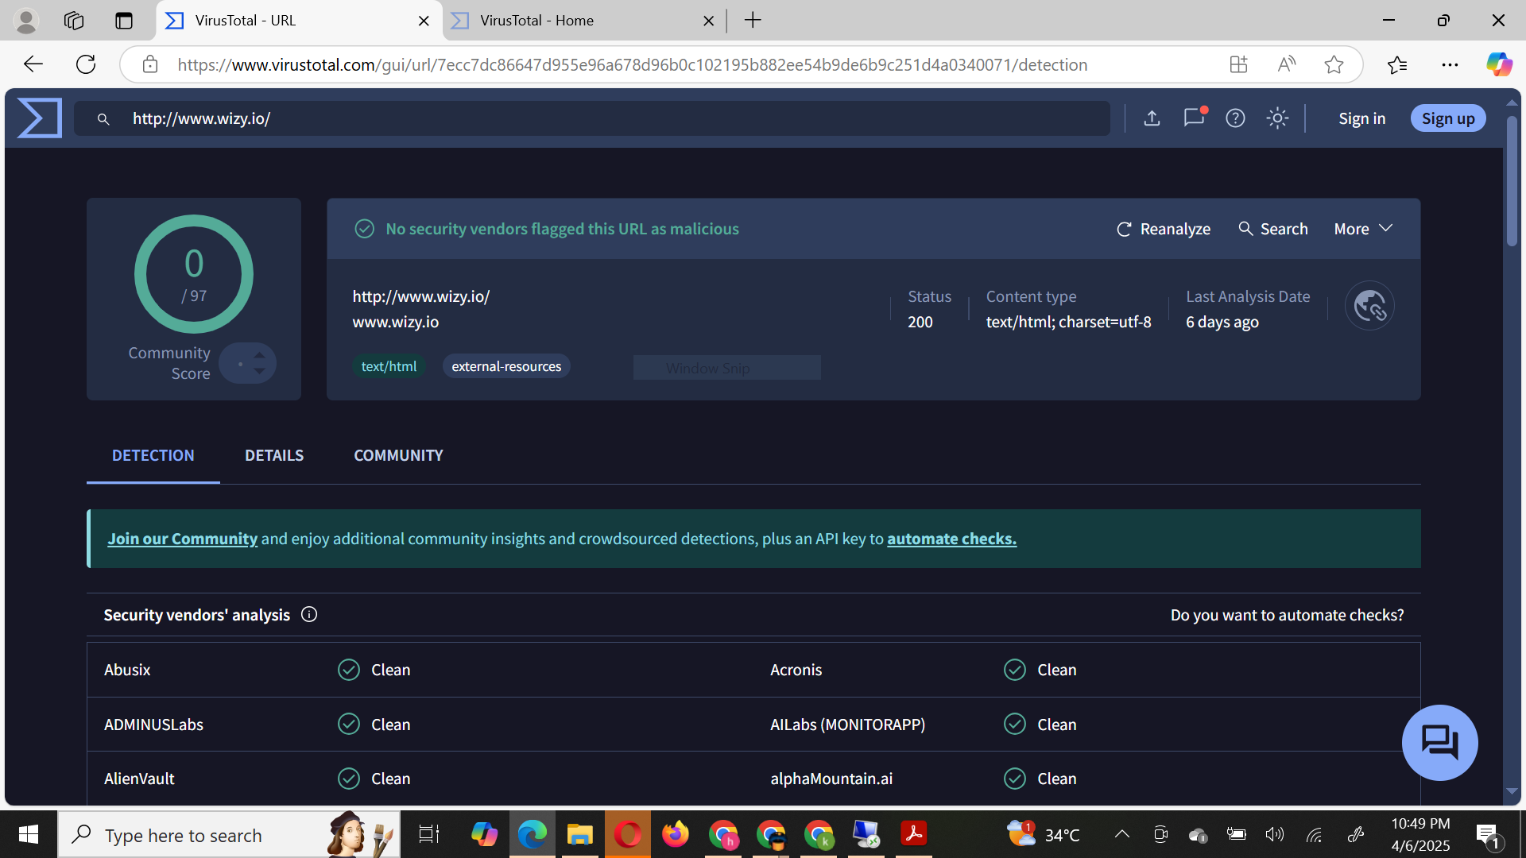

- Is URL #2 a malicious URL? Why or Why not? Explain.
Share screenshots of the results from Virustotal which provides evidence of your conclusion (malicious/not malicious) (3 points)

Answer:

The URL #2 is likely a malicious URL based on the fact that 15 out of 97 security vendors have flagged it as such, indicating potential phishing or other suspicious activities associated with this URL.

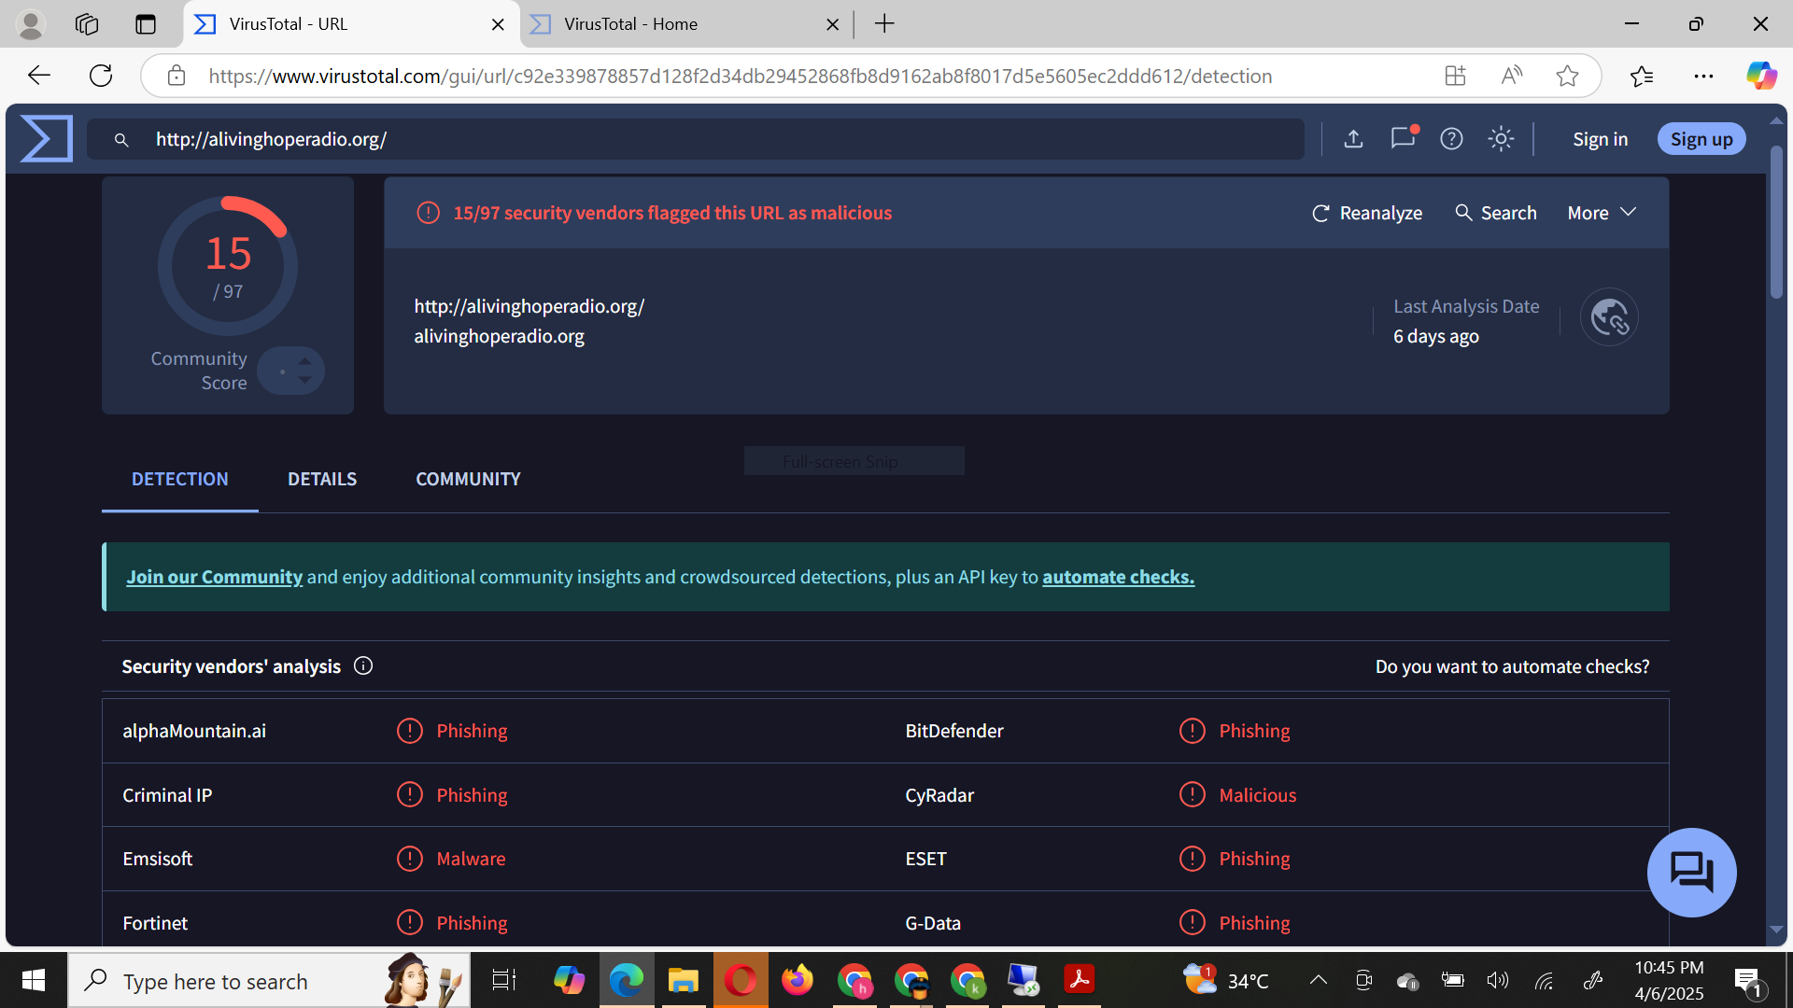

- Is URL #3 a malicious URL? Why or Why not? Explain.
Share screenshots of the results from Virustotal which provides evidence of your conclusion (malicious/not malicious) (3 points)

Answer:

The URL #3 is likely a malicious URL based on the fact that 12 out of 96 security vendors have flagged it as such, indicating potential phishing or other suspicious activities associated with this URL.
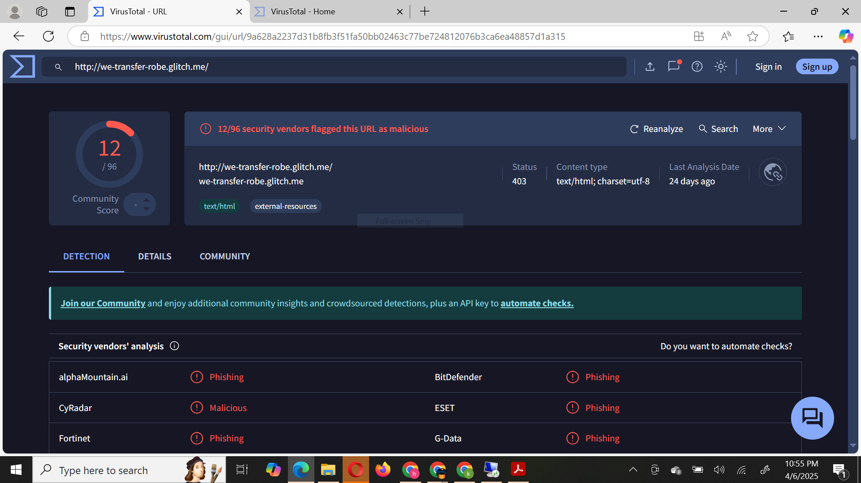

- Is URL #4 a malicious URL? Why or Why not? Explain.
Share screenshots of the results from Virustotal which provides evidence of your conclusion (malicious/not malicious) (3 points)

Answer:

Based on the security vendor analysis shown in the Virustotal, which indicates that the URL #4 is assessed as "Clean" by multiple reputable security vendors, this URL does not appear to be malicious.
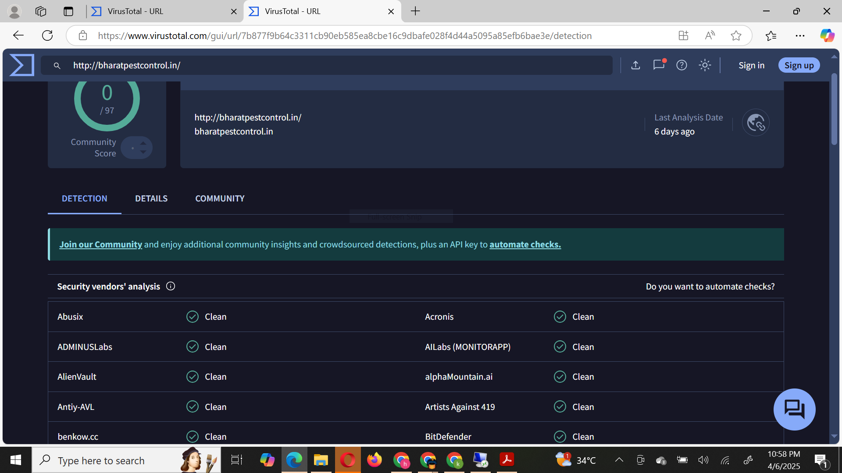

- Is URL #5 a malicious URL? Why or Why not? Explain.
Share screenshots of the results from Virustotal which provides evidence of your conclusion (malicious/not malicious) (3 points)

Answer:

The URL #5 is likely a malicious URL based on the fact that 12 out of 97 security vendors have flagged it as such, indicating potential phishing or other suspicious activities associated with this URL.

